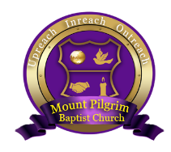
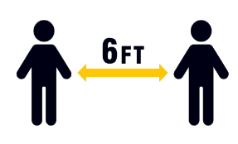
We are excited to announce our reassembly dates and plans. The date for reopening is Sunday, July 12th, 2020.
GUIDELINES FOR REOPENING
PROTECTIVE MASKS
All in attendance must wear mask. Free masks provided.
SOCIAL DISTANCING
We will sit in family groupings
TOUCHLESS EXPERIENCE
No touching, altar prayer or programs. Offering and\or Communion will be taken and distributed upon entry.
METICULOUS CLEANING
All facilities will be cleaned and professionally sanitized weekly.
RESTROOM MONITORS
Restroom capacity will be monitored. Children must be accompanied.
SANITIZER STATIONS
Touchless hand sanitizer stations will be in place.
CONTROLLED EGRESS
Welcome Center doors will be only entry and exit points.
We are excited to welcome you back to in-person worship. We encourage all members who are sick or feeling ill to stay home. We will continue to stream our service through Facebook and YouTube. There will be members and elders in place to give us direction throughout the worship experience. Please give them your respect and cooperation as they have been asked to ensure that we regather and worship safely. Our Sunday School and Bible Study will remain virtual at this time. Finally, worship service will begin at NOON and will last one hour. God bless you and we look forward to seeing you on July 12th, 2020.

Yours in Christ,

Pastor E
Officers & Trustees

